|  |
| --- |
| David School |
| Python Project File |
| Github : devasheeshG |
| Email : swastik.mishra.c322.smart@gmail.com |

|  |
| --- |
| Swastik mishra  2-28-2021 |

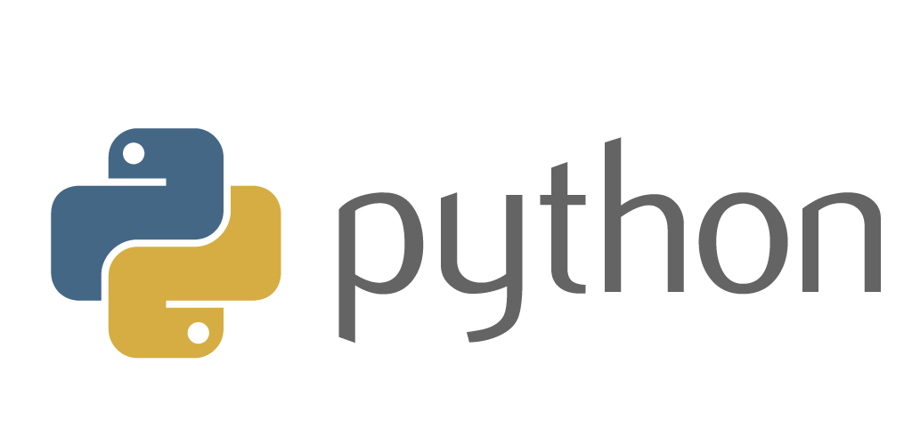

**Personal File**

Q1- Write a program that takes a number and checks whether the given number is even or odd.

## Source Code

# Python program to check if the input number is odd or even.

# A number is even if division by 2 gives a remainder of 0.

# If the remainder is 1, it is an odd number.

num = int(input("Enter a number: "))

if (num % 2) == 0:

print("{0} is Even".format(num))

else:

print("{0} is Odd".format(num))

**Output 1**

Enter a number: 43

43 is Odd

**Output 2**

Enter a number: 18

18 is Even

Q2-Write a program to accept three integers and print the largest of the three.

**Source Code**

# change the values of num1, num2 and num3 for a different result

num1 = 10

num2 = 14

num3 = 12

# uncomment following lines to take three numbers from user

#num1 = float(input("Enter first number: "))

#num2 = float(input("Enter second number: "))

#num3 = float(input("Enter third number: "))

if (num1 >= num2) and (num1 >= num3):

largest = num1

elif (num2 >= num1) and (num2 >= num3):

largest = num2

else:

largest = num3

print("The largest number is", largest)

**Output**

The largest number is 14.0

Q3. Write a program to print table of a given number by user.